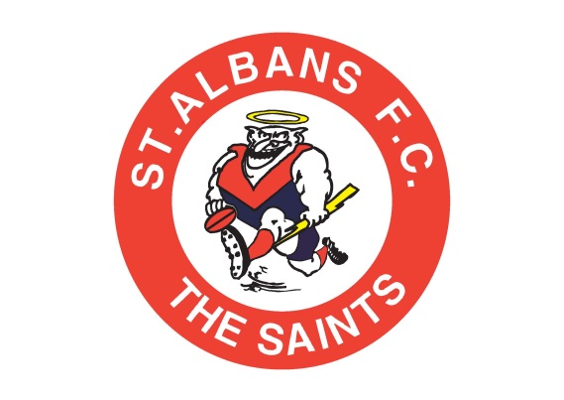

Drug Policy
ST ALBANS FOOTBALL CLUB
DRUG POLICY

The St Albans Football Club (STAFC) understands and accepts it has a duty of care to provide a safe and healthy environment, free of illegal drugs.

The STAFC is committed to:

- Encouraging and assisting members to realise their full potential within an environment that actively promotes their health, safety and well-being
- Preventing alcohol and other drug related harm to individuals, property and the reputation of the club
- Ensuring a supportive and inclusive environment for all members
- Providing support to members who wish to address their patterns of alcohol and/or illegal drug use
- Meeting legal requirements in relation to alcohol and illegal drugs
- Encouraging moderation and a responsible attitude to the consumption of alcohol

Purpose
The purpose of this policy is to ensure club members understand the club’s position regarding illegal drugs and explain how the club will respond to a drug-related incident within its jurisdiction.

Definitions

Illegal drugs
Illegal drugs are used by many people in the community, including young adults, so it is likely that some members of our club will have access to them. Currently there are two distinct but related illegal drug issues confronting sporting clubs:
- performance enhancing drugs
- illegal drugs used for social purposes (e.g. at parties, raves, in the home, at the club, etc).
These two categories are not mutually exclusive. Some illegal drugs used for social purposes (such as amphetamines, e.g. speed) may be used to enhance sporting performance.

Club jurisdiction
The Club jurisdiction extends to the club premises and all activities organised by or for the club at any location or venue.

Application
This policy applies to all members, employees, supporters and visitors of the STAFC. Members and employees should ensure they do not attend the club if adversely affected by illegal drugs and/or alcohol.

Illegal Drug Use

The possession, use, distribution or selling of illegal drugs for any purposes on club premises or at any function or activity organised by the club is prohibited.
- In the case of an incident involving an illegal drug, the initial actions and responses will focus on the safety and welfare of those directly and indirectly involved. All responses and actions will reflect the club’s duty of care to members, visitors and all other people.
- The club will investigate all apparent or alleged breaches of this policy and determine a course of action after all relevant facts and circumstances are known.
- The club may refer a member who is involved in illegal drug use to a medical or health service for assistance or, if the club deems it necessary in the circumstances, to the police.

If any member of our club is seen to be taking any illegal drugs wearing any part of the Club’s apparel, the following will occur;
- suspension for a designated time

This will remain to the discretion of the Clubs President.

Managing illegal drug incidents

Where a club member becomes aware that illegal drug use is occurring at the club or within its jurisdiction, the member should pass on this information to the President and/or Club official. Should the need arise, the Club will sanction the individual(s) in line with the club’s rules and policies.
The Club confidant will;
- Speak to the individual(s) in private, expressing concern about their drug use
- Remind the individual(s) of the club policy and asked for a commitment that it will not happen again
- Offer options for support and referral for counselling or other help
- Leave the door open for further communication with the individual(s) concerned.
- Inform the Club President in the event of non-compliance

If an individual(s) is under the influence of a legal or illegal drug at the club, the club will;
- Ensure the health and safety of the individual(s)
- Keep the individual under supervision and monitor them at regular intervals
- Call for medical assistance if required.
- Arrange safe transport to take them home, unless this involves further risk.
- Take control of any remaining drugs in their possession, unless this involves further risk.
- If the person becomes violent or aggressive, contact police to ensure the safety of all.
- Inform the Club President (and Club official) as soon as possible.

Supplying Illegal drugs

If it is suspected or known that a member is supplying illegal drugs to other members of the club, the Club official will;

Speak to the individual to determine if they are supplying illegal drugs to others.
- If it is unable to be verified, the club will monitor the situation and warn the individual that the matter will be reported to the police if the club has continued concerns.

Privacy

- Subject to its right to contact the police if necessary, the Club will maintain the privacy of those involved where possible
- The Club will act with discretion when absolute confidentiality cannot be guaranteed
- Club personnel will be informed on a need to know basis only

Contacting parents

- In the interests of health & safety, the Club will contact the parents or guardian of a minor where apparent or suspected illegal drug use has occurred (unless by doing so it will place the safety of the individual at risk of greater harm)
- The Club will inform all members aged under 18 years that parents will be notified if the club is aware (or strongly believes) they are using or supplying illegal drugs.
- If the member is aged over 18 years, the club will determine each case on its merits and decide whether contacting parents or guardian is in the best interests of the individual.

Medical emergency

The Club understands that medical assistance may be required if a person has been using drugs.

Media
- The Club will designate a club official to communicate with the media on behalf of the club should the need arise
- The Club may seek advice from the league/association prior to communicating with the media
- No other member of the club will communicate with the media on this issue, unless specifically requested by the club official

Non-compliance

All club committee members will enforce the illegal drug policy and any non-compliance will be handled according to the following process:
- The designated Club confidant (and President) will be informed of the breach of policy
- The individual(s) concerned will be reminded of the club policy
- Issue a warning of future sanctions for continued non-compliance

The Club official and President will use their discretion as to the action taken for non-compliance, based on:

- Whether it involved use or supply
- Whether the use or supply takes place within the club’s jurisdiction or in private
- Age of the persons involved

In general, and depending on any other rules of the club, should an individual(s) continue non-compliance with this policy, the following will occur;

- suspension for a designated time
- expulsion from the club.

Policy review
This policy will be reviewed annually to ensure it remains relevant to club operations and reflects both community expectations and legal requirements.

Endorsed by Club President, James Perkin
01/10/2018

